**IIT KHARAGPUR**

**ACADEMIC YEAR 21-22**

**DIY TEAM PROJECT REPORT**

**TEAM-9 PROJECT-16**

**AUTONOMOUS ARDUINO TRAFFIC LIGHTS**

Submitted by-

Anshul (21BT10006)

Busireddy Kruthika (21CH10019)

Shreya Sainath Desai (21EC30047)

Guided by-

Prof. C Mandal

Prof. Korak Sarkar

Prof. Sreeraj

**ACKNOWLEDGEMENT**

The success and the final outcome of this project required a lot of guidance and assistance from our professors. We are extremely fortunate to have got the guidance all along the completion of our project. We are thankful for getting the opportunity to do this project.

We are grateful because we managed to complete this project within the given time. This project could not have been completed without the efforts and co-operation from our group members.

**TABLE OF CONTENTS**

|  |  |
| --- | --- |
| S.NO | CONTENT |
| 1 | INTRODUCTION |
| 2 | RESEARCH |
| 3 | PLAN OF THE PROJECT |
| 4 | EXECUTION |
| 5 | FINAL MODEL |
| 6 | CREDITS |
| 7 | PROBLEMS FACED |
| 8 | CONCLUSION AND FUTURE SCOPE |

**INTRODUCTION**

This project is regarding autonomous Arduino traffic light. In this project we aspire to build an autonomous traffic light demonstration model.

The goal of this project is that we build a system which saves the time of the passengers. The system counts the number of vehicles present at a traffic signal and calculates the time for the green light such that it is enough for all the vehicles to pass. This saves the time of the people at the other side of the junction in case there are few vehicles at the current signal so that the green light doesn’t unnecessarily go on even if there are no vehicles passing. Also, a reckless driving alert system is to be implemented whereby the nearby traffic police are given an alert message when an over-speeding vehicle is detected.

Our project is divided into three sub-projects which are as follows:

* Basic model of traffic lights
* Speed detector using infrared sensor
* Vehicle detection and counting using opencv and python

We have put together these three sub-projects and came up with a final model which will be described in the upcoming sections.

**RESEARCH**

Congestion in traffic is a serious problem we face nowadays. Although it seems to pervade everywhere, mega cities are those most suffering from it. While insufficient capacity and unrestrained demand are somewhere interrelated, the delay of respective light is tough-coded and not hooked into traffic. Therefore, the necessity for simulating and optimizing control to accommodate this increasing demand arises. Conventional systems don’t handle variable flows approaching the junctions. This leads to traffic jam and congestion. In this project a system based on Arduino including IR sensors is built.

**TRAFFIC LIGHT MODULE:**

Traffic light module consists of red, yellow, and green LEDs, each of which has an individual control pin to which the digital high and low signals will be provided, and a common ground. It usually operates at 5V.

**IR SENSOR MODULE:**

The IR sensor module consists of IR Transmitter and Receiver, an opamp, a variable resistor (Trimmer pot), and an output LED. The IR LED (transmitter) emits light. The IR receiver, a photodiode, conducts when light falls on it. Photo- diode is a semiconductor which has a P-N junction, operated in reverse bias, which means that it starts conducting the current in reverse direction when light falls on it, proportional to the amount of light. This property makes it useful for IR detection. The IR transmitter and therefore the IR receiver are mounted on either side of a road. When an automobile passes on the road between the IR sensors, the system is activated and therefore the car count is incremented.

**VEHICLE DETECTION MODULE:**

We used OpenCV software with Python for image detection and counting. The Haar Cascade Classifier is the highlight of this sub-project. Haar Cascade Classifier is a method utilized for detecting object, also called as Viola Jones method due to its introduction by Paul Viola and Michael Jones for face detection. This method has 4 points for detecting an object, such as Haar-like feature, integral image, AdaBoost learning and Cascade Classifier. It uses positive and negative images to train itself using the methods specified above.

**PLAN OF THE PROJECT**

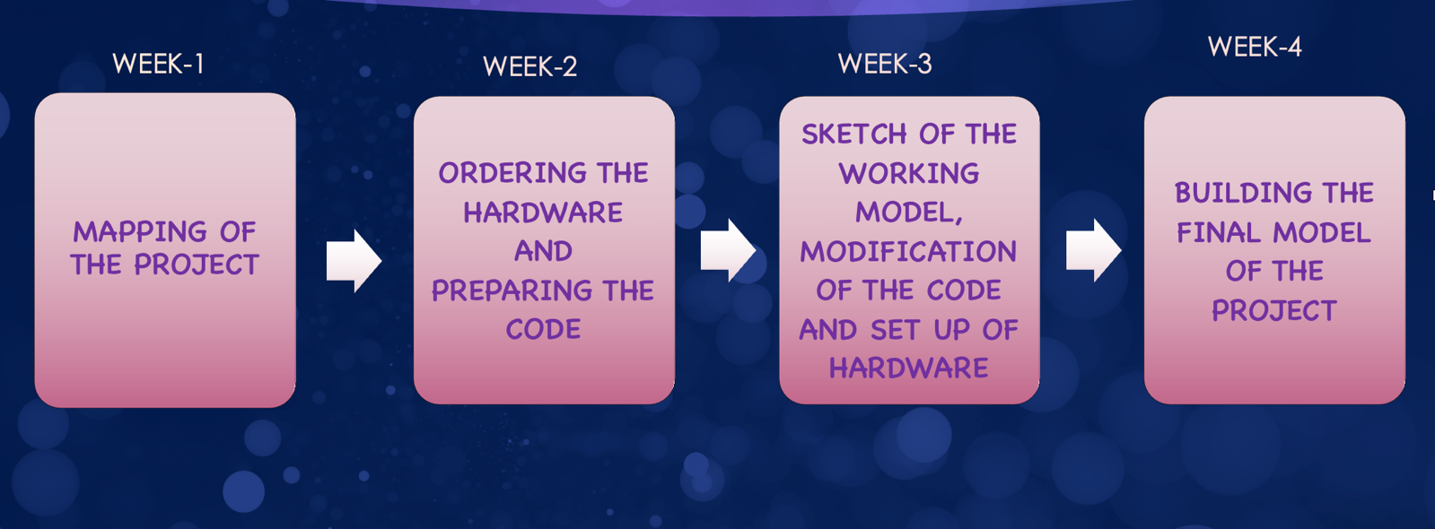

Firstly, we divided the project into three sub-projects and made a map of the project. Then we planned to order the hardware and prepare the code for three sub-projects individually. For the third week we thought of making a sketch of the working model and set up the hardware. Finally, we planned to complete the code and hardware part and build a demonstration model of the project in the fourth week.

**EXECUTION**

We gathered requisite amount of information about the sub-projects and studied them. Then we ordered the hardware parts.

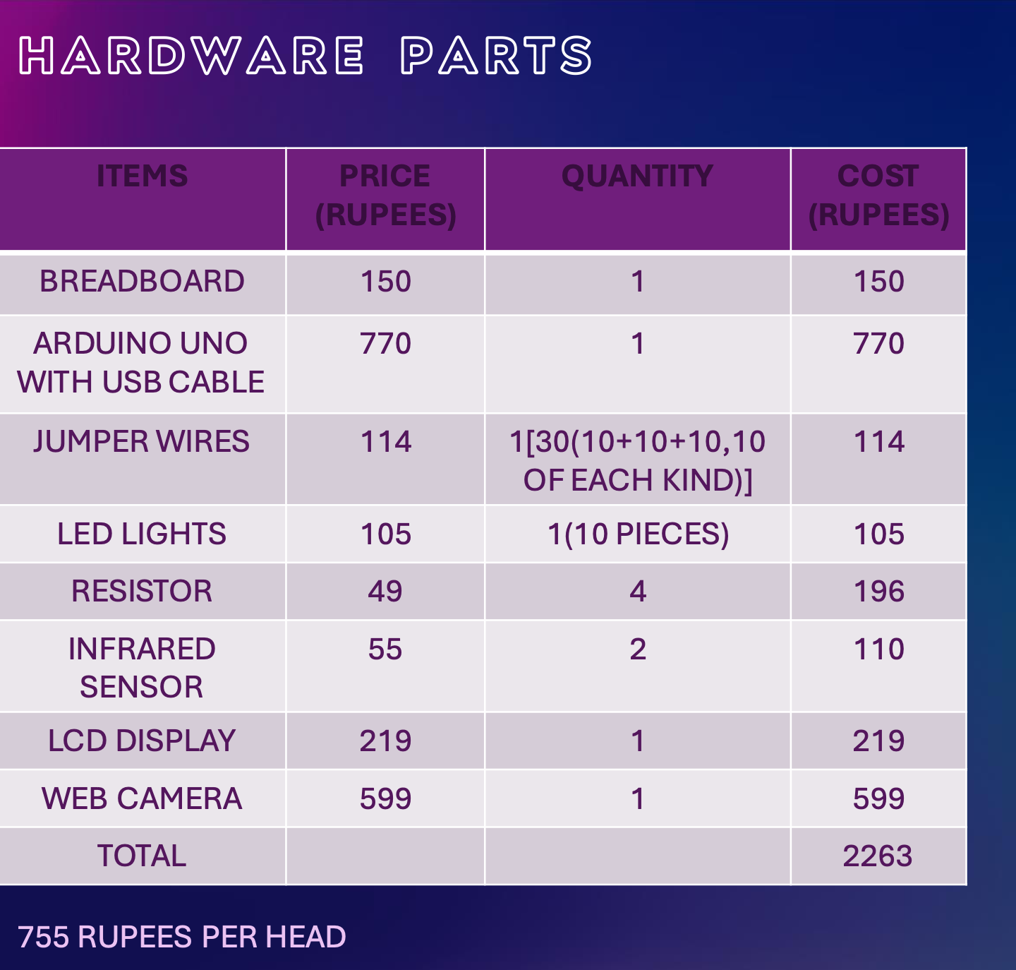

We started preparing the code for the project. To build a final model of the project for demonstration we made a sketch of the working model and started setting up the hardware. Earlier when we planned the project, we had an idea of using a video for detecting and counting the vehicles. But we realized that we really don’t need a video as a picture would work perfectly well for the same cause as the cars are static at the signal. So, we modified the code for performing the same action on a picture which made the code much more precise and efficient. It also helped us cutting down the cost of a webcam. Hence reducing the cost of the project by 600 rupees. Finally, in the last week we built the physical model of the project.

**FINAL MODEL**

**CREDITS**

**ANSHUL:** Basic model of Arduino traffic lights, Hardware and physical model of the project, Assistance in coding, Editing and Animation, Presentation (week-1)

**BUSIREDDY KRUTHIKA:** Speed detection using IR sensors, Coding, Sketch of the project, lab report, schematic diagram in Tinkercad and Presentation (week-3,4)

**Shreya Sainath Desai:** Code for vehicle detection and counting using OpenCV and Python, Modification and compilation of the code and Final circuit, Demonstration video, editing and presentation (week-2)

**PROBLEMS FACED**

We have made this model for real cars which means the classifier used here is trained for real cars. But in our model, we will be using toy cars and the real car classifier will not be able to detect the toy cars. The Cascade files of common objects are available on internet (like of the real cars) but we were not able to find the Cascade file for the toy cars.

**SOLUTION:**

We used Cascade trainer GUI for training the classifier to detect the toy car and created our own Cascade file for the toy cars.

**CONCLUSION AND FUTURE SCOPE**

The project ‘Autonomous Arduino traffic lights’ has been developed as per the requirement specification. It has been developed to control the traffic lights automatically using Arduino. We have successfully implemented the code on the Arduino with speed detection feature. In this project we developed Autonomous traffic lights which will also be capable of detecting and counting the number of vehicles. Then it will automatically set the green light timer long enough for all the vehicles to pass so that the vehicles at the other signals don’t have to wait unnecessarily.

The level of sophistication is quite low and hence its working is user friendly. This project can also be subjected to standardization and hence has a good future scope.

In future, this project can be extended to implement the automatic speed detection feature. It helps in capturing speed of vehicles without any human involvement. This project can also be used as traffic logger, traffic counter and few other traffic related applications.